VISHAAL SV 192412349
ECA0502 EMF

EXP 2
Determination and plotting of Electric field and Electric flux density in sphere full of charges with varying radius.
PROGRAM:
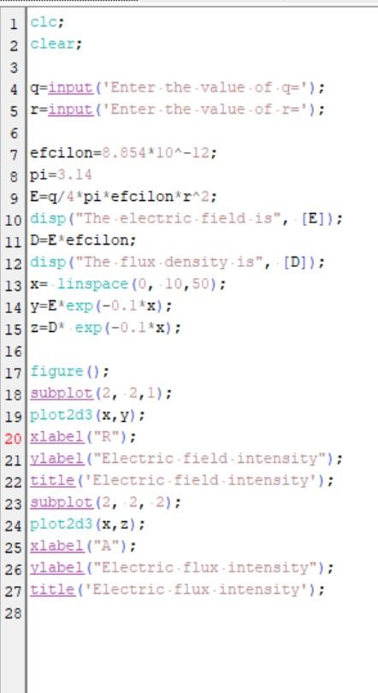

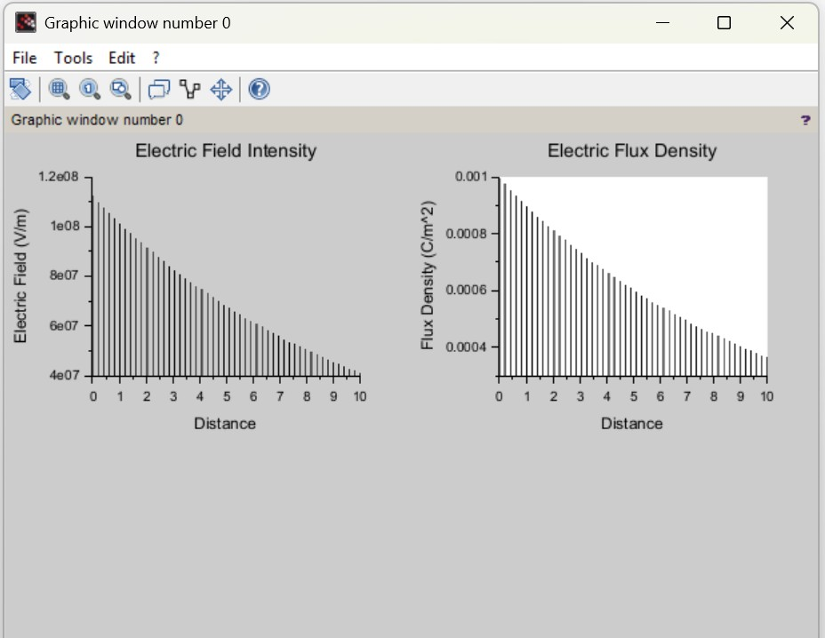

OUTPUT:
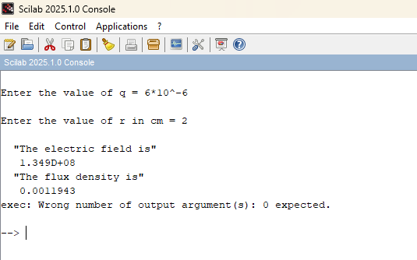
OBSERVATION:
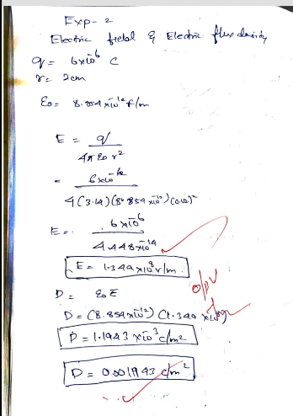
CASE 1:
PROGRAM:
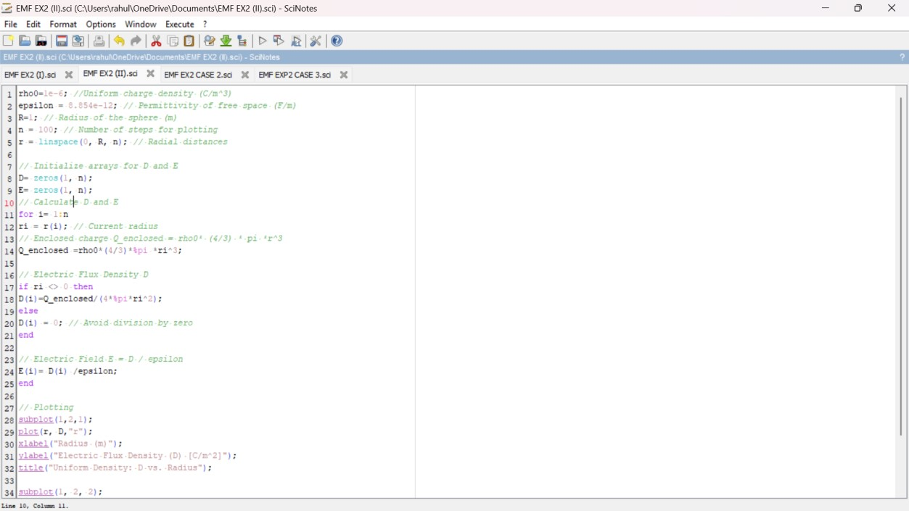
OUTPUT:
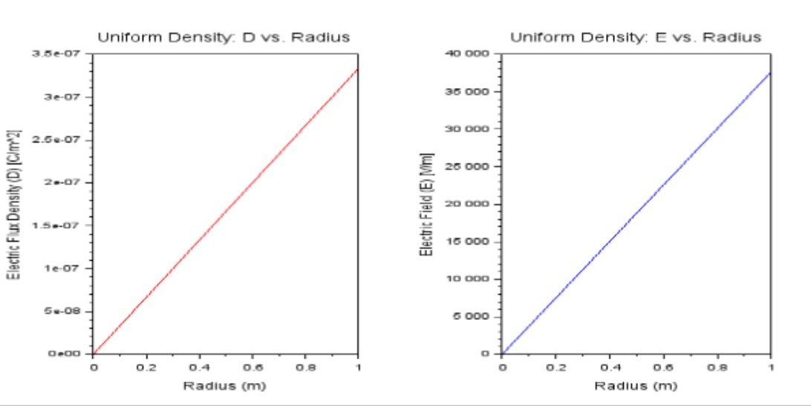

CASE 2:
PROGRAM:
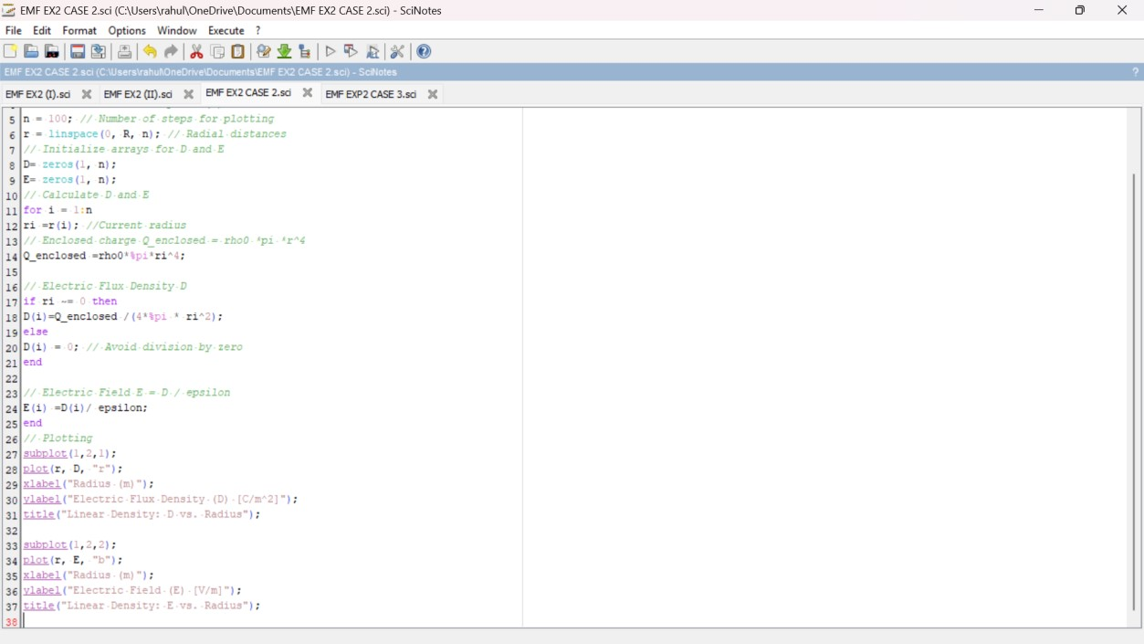
OUTPUT:
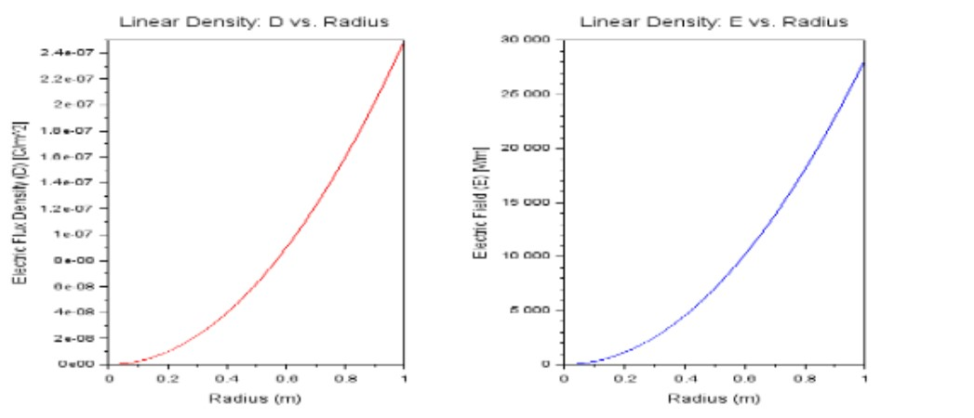

CASE 3:
PROGRAM:
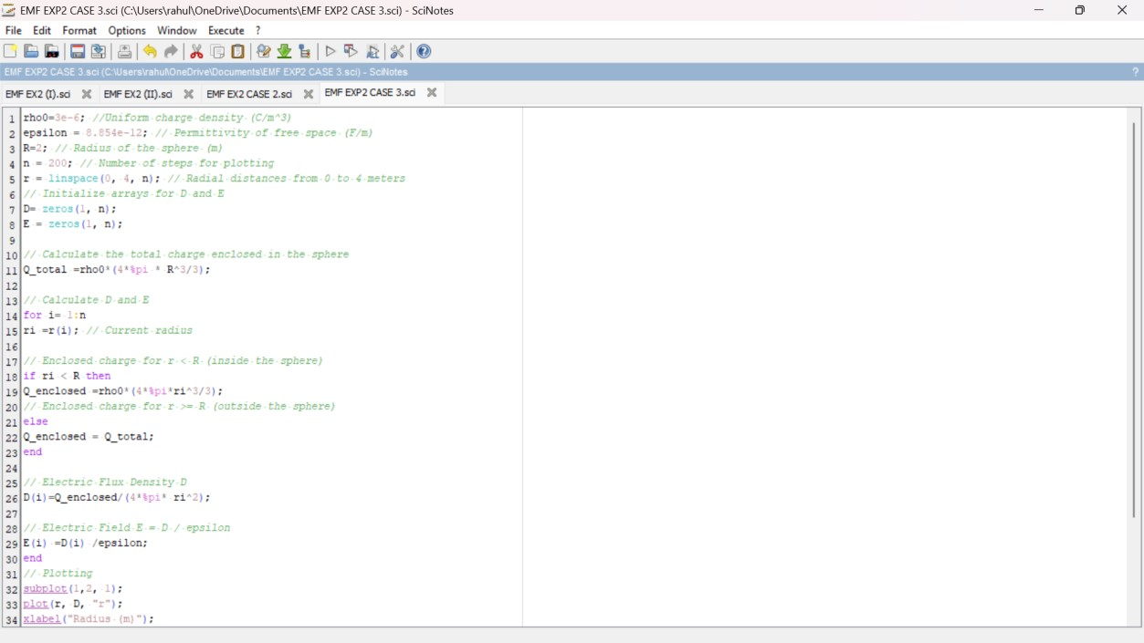
OUTPUT:
